PRN: 260740150012
260740150025
Day 3: Lab Exercises — Distributed Computing (MPI) & Asynchronous Programming

Exercise 1: MPI Token Ring Communication
Topics: mpi4py, Point-to-point communication, comm.sendrecv(), non-blocking isend/irecv

Problem Statement
Write an MPI script ex01_mpi_ring.py that implements a circular token-passing ring across all ranks:

Rank 0 ───> Rank 1 ───> Rank 2 ───> Rank 3 ───> Rank 0
- Initialize MPI with comm = MPI.COMM_WORLD, finding your rank and size.
- Ensure the script runs with at least 3 processes (mpirun -n 4 python3 ex01_mpi_ring.py).
- Set up the ring topology:
Next rank: (rank + 1) % size
Previous rank: (rank - 1 + size) % size
- Token Passing:
Rank 0 originates a token: token = {"hops": 0, "history": [0]}.
Rank 0 sends the token to Rank 1 and then waits to receive the final token from Rank (N − 1).
Intermediate ranks wait to receive the token from the previous rank, increment hops += 1, append their rank to history, and forward the token to the next rank.
- Prevent deadlocks:
Use comm.sendrecv() or non-blocking comm.isend() / comm.irecv().
- When the token returns to Rank 0, print the total hop count and the path traversal history.
Hints & Guidelines
  - Launch your program using: mpirun -n 4 python3 ex01_mpi_ring.py.
  - If testing on a machine without mpi4py, write the code using standard mpi4py syntax and test under simulated conditions or within an MPI-enabled container/virtual machine.

Best Practices
  - Ring topologies are classic synchronization primitives in distributed algorithms.
  - Always use modular arithmetic (% size) to cleanly wrap around boundary ranks.
Code:
import sys
from mpi4py import MPI

def main():
comm = MPI.COMM_WORLD
rank = comm.Get_rank()
size = comm.Get_size()

if size < 3:
if rank == 0:
print(
f"Error: Minimum 3 processes required. Current size: {size}",
flush=True,
)
sys.exit(1)

next_rank = (rank + 1) % size
prev_rank = (rank - 1 + size) % size

if rank == 0:
token = {"hops": 0, "history": [0]}
print(f"[Rank 0] Originating token: {token}", flush=True)

final_token = comm.sendrecv(
sendobj=token, dest=next_rank, source=prev_rank
)

final_token["hops"] += 1
final_token["history"].append(0)

print("\n--- Token Ring Completed ---", flush=True)
print(f"Total Hops: {final_token['hops']}", flush=True)
print(f"Path Traversal History: {final_token['history']}", flush=True)
else:
token = comm.recv(source=prev_rank)

token["hops"] += 1
token["history"].append(rank)
print(f"[Rank {rank}] Received token: {token}", flush=True)

comm.send(token, dest=next_rank)

if __name__ == "__main__":
main()

Output:
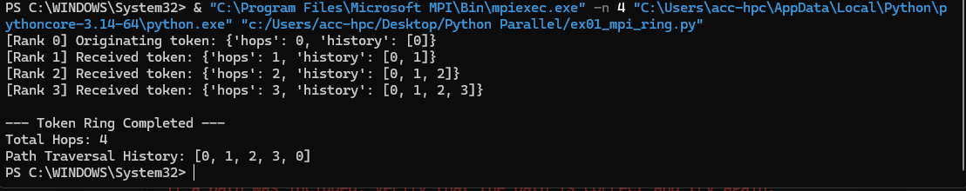

Exercise 2: Distributed Monte Carlo Pi with MPI Collectives
Topics: comm.bcast, comm.scatter, comm.reduce, MPI.SUM, parallel reduction

Problem Statement
Write an MPI script ex02_mpi_collective_pi.py that computes π in parallel using collective operations:
- Broadcast Configuration:
  - Rank 0 specifies the total number of Monte Carlo samples (e.g., 12, 000, 000).
  - Rank 0 broadcasts this number to all processes using comm.bcast(total_samples, root=0).
- Parallel Sampling:
  - Each rank calculates its local quota: local_samples = total_samples // size.
  - Each rank seeds its random number generator with random.seed(rank * 100 + 42) to
ensure independent sample generation.
  - Each rank generates points (x, y) ∈ [0, 1] × [0, 1] and counts how many satisfy x² + y² ≤ 1.
- Global Reduction:
  - Use comm.reduce(local_inside, op=MPI.SUM, root=0) to sum the points inside the unit circle across all ranks onto Rank 0.
- Result Calculation:
  - On Rank 0, compute the approximation: π ≈ 4 × ^{total_inside} .
total_samples
  - Print the calculated value, the error compared to math.pi, and the execution runtime.
Hints & Guidelines
- Every process in the communicator must call comm.bcast() and comm.reduce(). If any rank omits the collective call, all other processes will hang!
- Notice that no process ever sends raw random coordinates over the network—only the single aggregated scalar integer is reduced, maximizing network efficiency.

Best Practices
- Never transmit bulk raw data if the reduction can be performed locally on each node first.
- In collective communication, ensure that non-root ranks pass root=0 as an argument.
Code:
import math
import random
from mpi4py import MPI

def main():
comm = MPI.COMM_WORLD
rank = comm.Get_rank()
size = comm.Get_size()

if rank == 0:
total_samples = 12_000_000
else:
total_samples = None

comm.Barrier()
start_time = MPI.Wtime()

total_samples = comm.bcast(total_samples, root=0)

local_samples = total_samples // size
random.seed(rank * 100 + 42)

local_inside = 0
for _ in range(local_samples):
x = random.random()
y = random.random()
if x * x + y * y <= 1.0:
local_inside += 1

total_inside = comm.reduce(local_inside, op=MPI.SUM, root=0)

comm.Barrier()
end_time = MPI.Wtime()

if rank == 0:
actual_samples = local_samples * size
pi_approx = 4.0 * total_inside / actual_samples
error = abs(pi_approx - math.pi)
elapsed_time = end_time - start_time

print(f"Processes (Ranks) : {size}", flush=True)
print(f"Total Samples : {actual_samples:,}", flush=True)
print(f"Calculated Pi : {pi_approx:.8f}", flush=True)
print(f"Actual Pi : {math.pi:.8f}", flush=True)
print(f"Absolute Error : {error:.8e}", flush=True)
print(f"Execution Time : {elapsed_time:.4f} seconds", flush=True)

if __name__ == "__main__":
main()

Output:
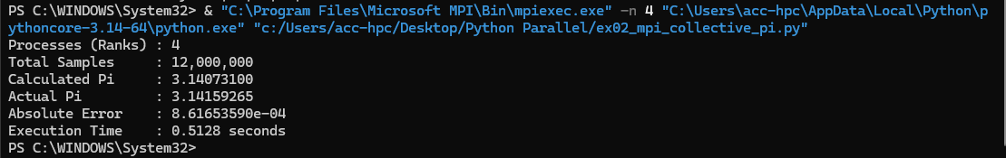
Exercise 3: High-Level Concurrency with ThreadPoolExecutor
Topics: concurrent.futures, ThreadPoolExecutor, as_completed(), timeouts

Problem Statement

Write a script ex03_futures_downloader.py that fetches simulated resources concurrently:
- Define a list of 10 simulated web endpoints with varying simulated network delays (between 0.2 and 1.5 seconds).
- Create a worker function download_endpoint(url):
  - Simulates network latency using time.sleep().
  - If the URL ends with .error, deliberately raise a ConnectionError.
  - Otherwise, returns a string containing the downloaded payload.
- Use concurrent.futures.ThreadPoolExecutor(max_workers=5):
  - Submit all 10 download tasks using executor.submit().
  - Map each returned Future object back to its URL using a dictionary.
- Use as_completed() to iterate over results as soon as they finish:
  - Handle successful downloads and print their byte sizes.
  - Catch and log exceptions gracefully when encountering .error URLs without crashing the script.
  - Implement a per-task timeout using future.result(timeout=1.0) to abort endpoints that take too long.
Hints & Guidelines
- as_completed(future_dict) yields Futures in the order they complete, not in the order they were submitted.
- Accessing future.result() re-raises any exception that was thrown inside the worker thread.

Best Practices
- Always attach timeouts to futures when making network or external system calls.
- Use ThreadPoolExecutor for I/O-bound tasks and ProcessPoolExecutor for CPU-bound tasks with the exact same API.
Code:
import random
import time
from concurrent.futures import ThreadPoolExecutor, TimeoutError, as_completed

ENDPOINTS = [
"https://api.example.com/data1.json",
"https://api.example.com/data2.json",
"https://api.example.com/data3.error",
"https://api.example.com/data4.json",
"https://api.example.com/data5.json",
"https://api.example.com/data6.json",
"https://api.example.com/data7.error",
"https://api.example.com/data8.json",
"https://api.example.com/data9.json",
"https://api.example.com/data10.json",
]

def download_endpoint(url):
delay = random.uniform(0.2, 1.5)
time.sleep(delay)

if url.endswith(".error"):
raise ConnectionError(f"Failed to connect to {url}")

return f"Payload from {url} (Latency: {delay:.2f}s)"

def main():
print("Starting download tasks...\n", flush=True)

with ThreadPoolExecutor(max_workers=5) as executor:
future_to_url = {
executor.submit(download_endpoint, url): url for url in ENDPOINTS
}

for future in as_completed(future_to_url):
url = future_to_url[future]
try:
result = future.result(timeout=1.0)
byte_size = len(result.encode("utf-8"))
print(
f"[SUCCESS] {url} -> Downloaded {byte_size} bytes",
flush=True,
)
except TimeoutError:
print(
f"[TIMEOUT] {url} -> Task exceeded 1.0s limit", flush=True
)
except ConnectionError as e:
print(f"[ERROR] {url} -> {e}", flush=True)
except Exception as e:
print(f"[UNEXPECTED ERROR] {url} -> {e}", flush=True)

if __name__ == "__main__":
main()

Output:
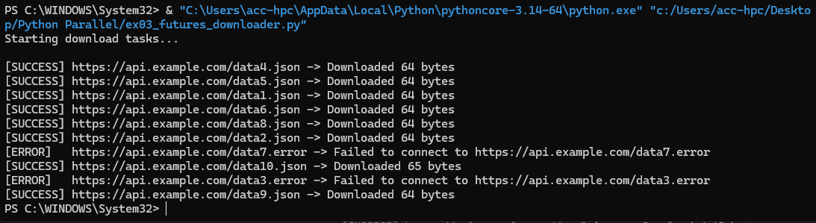
Exercise 4: Cooperative Concurrency with asyncio
Topics: asyncio, async def, await, asyncio.gather(), event loop

Problem Statement
Write an asynchronous monitoring tool ex04_async_monitor.py using Python's asyncio:
- Define three asynchronous coroutines simulating microservice health checks:
check_database(): Takes 0.4s (await asyncio.sleep(0.4)), returns {"db": "HEALTHY", "latency_ms": 12}.
check_redis_cache(): Takes 0.2s, returns {"cache": "HEALTHY", "latency_ms": 4}.

check_storage_service(): Takes 0.6s, returns {"storage": "HEALTHY", "latency_ms": 28}.
- Write a top-level coroutine run_health_checks():
Uses asyncio.gather() to launch all three health checks concurrently on the single-threaded event loop.
Records the total time taken to complete all checks.
Verifies that the total execution time is roughly equal to the slowest individual check (~0.6s), rather than the sum of all three (0.4 + 0.2 + 0.6 = 1.2s).
- Run the top-level coroutine using asyncio.run().
Hints & Guidelines
  - Never call blocking functions like time.sleep() inside coroutines—always use await asyncio.sleep().
  - Coroutine functions declared with async def do not run when called; they return a coroutine object that must be awaited or scheduled on the event loop.

Best Practices
  - asyncio is far more scalable than threads for network I/O, capable of managing tens of thousands of active socket connections with negligible memory overhead.
  - Use asyncio.gather() when you have a known set of concurrent tasks and need all of their results returned together.
Code:
import asyncio
import time

async def check_database():
await asyncio.sleep(0.4)
return {"db": "HEALTHY", "latency_ms": 12}

async def check_redis_cache():
await asyncio.sleep(0.2)
return {"cache": "HEALTHY", "latency_ms": 4}

async def check_storage_service():
await asyncio.sleep(0.6)
return {"storage": "HEALTHY", "latency_ms": 28}

async def run_health_checks():
start_time = time.perf_counter()

results = await asyncio.gather(
check_database(), check_redis_cache(), check_storage_service()
)

elapsed_time = time.perf_counter() - start_time

print("--- Health Check Results ---", flush=True)
for result in results:
print(result, flush=True)

print(
f"\nTotal Execution Time: {elapsed_time:.2f} seconds", flush=True
)

def main():
asyncio.run(run_health_checks())

if __name__ == "__main__":
main()

Output:
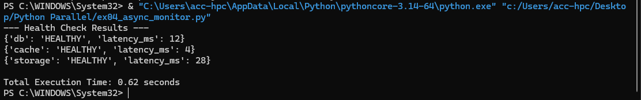
Exercise 5: Bridging Asyncio with CPU-Heavy Workloads
Topics: asyncio.create_task(), task cancellation, loop.run_in_executor()

Problem Statement
Write a script ex05_async_cpu_bridge.py that demonstrates how to execute heavy CPU computation alongside an active asynchronous event loop:
- The Problem:
  - If a coroutine executes a heavy for loop or matrix calculation directly, it blocks the single-threaded event loop, freezing all other asynchronous tasks!
- The Solution:
  - Create a background heartbeat coroutine heartbeat_ticker() that prints "[Heartbeat] Active and responsive..." every 0.25 seconds.
  - Create a heavy synchronous CPU function fibonacci_cpu(n) that calculates a large Fibonacci or prime number.
- In the main async function:
  - Start the heartbeat as a background task using asyncio.create_task().

  - Obtain the running event loop using loop = asyncio.get_running_loop().
  - Offload fibonacci_cpu to the default thread pool executor using await loop.run_in_executor(None, fibonacci_cpu, 35).
  - Observe that the heartbeat ticker continues printing regularly while the CPU function
calculates in the background!
  - Cancel the heartbeat task cleanly using task.cancel() once the calculation finishes.
Hints & Guidelines
- loop.run_in_executor(None, func, *args) runs func in a background
ThreadPoolExecutor and returns an asyncio Future that can be awaited.
- Catch asyncio.CancelledError inside the heartbeat task to allow it to perform clean exit procedures.

Best Practices
- Never allow CPU-bound work or synchronous third-party libraries to execute on the main asyncio
thread.
- Always cancel or await background tasks before shutting down an asyncio event loop to avoid Task was destroyed but it is still pending warnings.
Code:
import asyncio
import time

def fibonacci_cpu(n):
if n <= 1:
return n
return fibonacci_cpu(n - 1) + fibonacci_cpu(n - 2)

async def heartbeat_ticker():
try:
while True:
print("[Heartbeat] Active and responsive...", flush=True)
await asyncio.sleep(0.25)
except asyncio.CancelledError:
print("[Heartbeat] Stopped cleanly.", flush=True)

async def main():
heartbeat_task = asyncio.create_task(heartbeat_ticker())

loop = asyncio.get_running_loop()

print("Starting heavy CPU task in background executor...", flush=True)
start_time = time.perf_counter()

result = await loop.run_in_executor(None, fibonacci_cpu, 35)

elapsed_time = time.perf_counter() - start_time
print(
f"Fibonacci(35) Result: {result} (Took {elapsed_time:.2f}s)",
flush=True,
)

heartbeat_task.cancel()
await asyncio.gather(heartbeat_task, return_exceptions=True)

if __name__ == "__main__":
asyncio.run(main())

Output:
